

computerization of bit, deoghar

ASSIGNMENT 03



**ASSIGNMENT: 3**

**TOPIC: DATA DICTIONARY**

**DATABASE TABLE**

**MODULE 01: COMPUTER SCIENCE AND ENGINEERING DEPARTMENT**

**FILE 01**

1. **File name/database name: faculty table**
2. **File type: database table**
3. **File description: record the information of the faculties of CSE department**
4. **Attributes name and attribute type of the file:**

**Faculty_ name | varchar;**

**Faculty_ code | varchar;**

**Faculty_ mail | varchar;**

**Mobile_ number | numeric;**

**Faculty_ address | varchar;**

**Faculty_ date_ of_ birth | date;**

**Faculty_ joining_ date | date;**

1. **Number of records in the file: 12**

**FILE 02**

1. **File name/database name: student table**
2. **File type: database table**
3. **File description: record the information of the student of CSE department from first year to final year**
4. **Attributes name and attribute type of the file:**

**Student name | varchar;**

**Student code | varchar;**

**Student mail | varchar;**

**Mobile number | numeric;**

**Student address | varchar;**

**Student date of birth | date;**

1. **Number of records in the file: 250**

**FILE 03**

1. **File name/ database name: student result table**
2. **File type: database table**
3. **File description: record the marks scored in all the exams conducted class-wise**
4. **Attributes name and attribute type of the file:**

**Student name varchar;**

**Student roll numeric;**

**semester numeric;**

**marks enter numeric;**

1. **Number of records in the file: 100**

**FILE 04**

1. **File name/ database name: course structure table**
2. **File type: database table**
3. **File description: records all the subject that is to be studied in each semester**
4. **Attributes name and attribute type of the file:**

**Subject code numeric;**

**Subject name varchar;**

**Credit numeric;**

**Type lecturer/sessional;**

1. **Number of records in the file:10**

**FILE 05**

1. **File name/ database name: login table**
2. **File type: meta data**
3. **File description: it will have the list of all the user and their password.**
4. **Attributes name and attribute type of the file:**

**Login varchar;**

**Password varchar;**

1. **Number of records in the file:50**

**FILE 06**

1. **File name/database name: notice board table**
2. **File type: database table**
3. **File description: it will contain the list of all event to be taken place in a week.**
4. **Attributes name and attribute type of the file:**

**Event_ name varchar;**

**Date Date;**

**Time time;**

1. **Number of records in the file: 50**

**FILE 07**

1. **File name/database name: induction program table**
2. **File type: database table**
3. **File description: it will contain the list of all the event other than study event that is to be conducted.**
4. **Attributes name and attribute type of the file:**

**Event_ name varchar;**

**Date date;**

**Time time;**

**Event_ guest varchar;**

1. **Number of records in the file: 50**

**FILE 08**

1. **File name/database name: specialization and minor subject table**
2. **File type: database table**
3. **File description: it will contain list of all the subject that will be studied under specialization and minor subject.**
4. **Attributes name and attribute type of the file:**

**Subject_ code varchar;**

**Subject_ name varchar;**

**Credit numeric;**

**Duration numeric;**

1. **Number of records in the file: 50**

**MODULE 02: CLUBS AND SOCIETY DEPARTMENT**

**FILE 01**

1. **File name/ database name: program list table**
2. **File type: database table**
3. **File description: it will have list of all program that is to take place**
4. **Attributes name and attribute type of the file:**

**Program name varchar;**

**Program code numeric;**

**Program time time;**

**Program date date;**

1. **Number of records in the file:10**

**FILE 02**

1. **File name/ database name: student committee table**
2. **File type: database table**
3. **File description: it contains list of all student who holds the post**
4. **Attributes name and attribute type of the file:**

**Name varchar;**

**Roll no. numeric;**

**Post name varchar;**

**Email_id varchar;**

1. **Number of records in the file:12**

**FILE 03**

1. **File name/database name: student participant table**
2. **File type: database table**
3. **File description: it contains the list of all student who have register for the event**
4. **Attributes name and attribute type of the file:**

**Name varchar;**

**Roll no. numeric;**

**Email varchar;**

**Phone numeric;**

**Batch numeric;**

1. **Number of records in the file:50**

**MODULE 03: GIRL’S HOSTEL DEPARTMENT**

**FILE 01**

1. **File name/ database name: student detail table**
2. **File type: database table**
3. **File description: it contains list all student living in hostel**
4. **Attributes name and attribute type of the file:**

**Name varchar;**

**Roll no. numeric;**

**Email varchar;**

**Phone numeric;**

**Address varchar;**

**Branch varchar;**

**Batch varchar;**

**Gender varchar;**

1. **Number of records in the file: 200**

**FILE 02**

1. **File name/ database name: hostel staff table**
2. **File type: database table**
3. **File description: it will contain the list of all staff member who help in functioning of hostel.**
4. **Attributes name and attribute type of the file:**

**Name varchar;**

**Employee ID numeric;**

**Address varchar;**

**Phone numeric;**

**Date of joining date;**

**Post holding varchar;**

1. **Number of records in the file: 100**

**FILE 03**

1. **File name/ database name: room table**
2. **File type: database table**
3. **File description: it contains the details of the room present in the hostel.**
4. **Attributes name and attribute type of the file:**

**Room ID numeric;**

**Room type varchar;**

**Bed_ number numeric;**

**Bed_ type varchar;**

1. **Number of records in the file: 200**

**FILE 04**

1. **File name/ database name: login table**
2. **File type: meta data**
3. **File description: it will be accessible those who have registered in hostel portal**
4. **Attributes name and attribute type of the file:**

**Login varchar;**

**Password varchar;**

1. **Number of records in the file: 100**

**FILE 05**

1. **File name/database name: electric equipment table**
2. **File type: database table**
3. **File description: it will contain list of all electric equipment provided in a room.**
4. **Attributes name and attribute type of the file:**

**Room_ number numeric;**

**Bulb_ type varchar;**

**Fan_ type varchar;**

1. **Number of records in the file: 100**

**FILE 06**

1. **File name/ database name: internet_ access_ info**
2. **File type: database table**
3. **File description: it will contain list of students who accessing hostel internet.**
4. **Attribute type and attribute type of the file:**

**Name varchar;**

**Roll_ no numeric;**

**Wifi_code varchar;**

**Wifi_ password varchar;**

**Duration time;**

1. **Number of records in the file: 100**

**FILE 07**

1. **File name/ database name: mess schedule table**
2. **File type: database table**
3. **File description: it will contain mess menu for a semester per day.**
4. **Attribute name and attribute type of the file:**

**Day varchar;**

**Breakfast varchar;**

**Lunch varchar;**

**Snack varchar;**

**Dinner varchar;**

**Time time;**

1. **Number of records in the file: 10**

**MODULE 04: EXAMINATION DEPARTMENT**

**FILE 01**

1. **File name/ database name: student result table**
2. **File type: database table**
3. **File description: it contains the detail of the result of student.**
4. **Attributes name and attribute type of the file:**

**Name varchar;**

**Roll no. numeric;**

**Semester numeric;**

**Subject numeric;**

**Marks numeric;**

**Passed/failed varchar;**

**Grade varchar;**

1. **Number of records in the file: 100**

**FILE 02**

1. **File name/ database name: subject table**
2. **File type: database table**
3. **File description: it will contain the list of the subject that examination to be held.**
4. **Attribute name and attribute type of the file:**

**Subject_ code integer;**

**Subject_ name varchar;**

**Question_ id integer;**

**Optional_ ID varchar;**

**Answer_ ID varchar;**

1. **Number of records in the file: 100**

**DATABASE FILE**

**COMPUTER SCIENCE AND ENGINEERING DEPARTMENT**

**FILE 01**

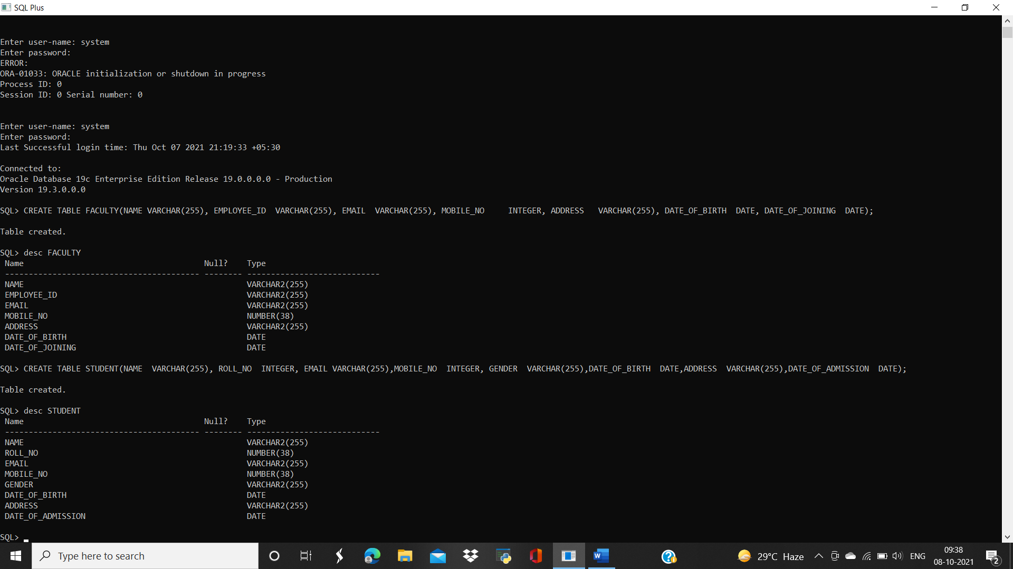

**FILE 02**



**FILE 03**

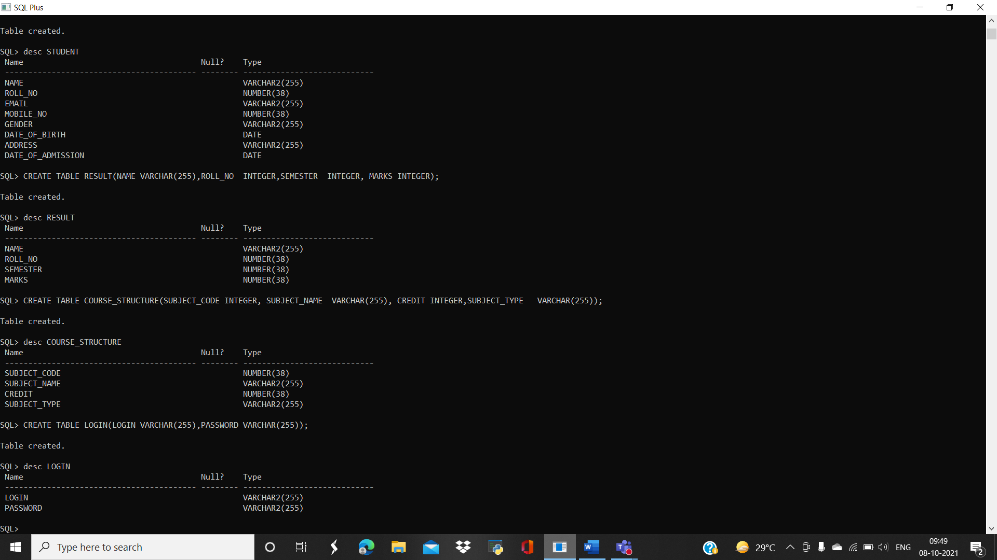

**FILE 04**



**FILE 05**



**FILE 06**

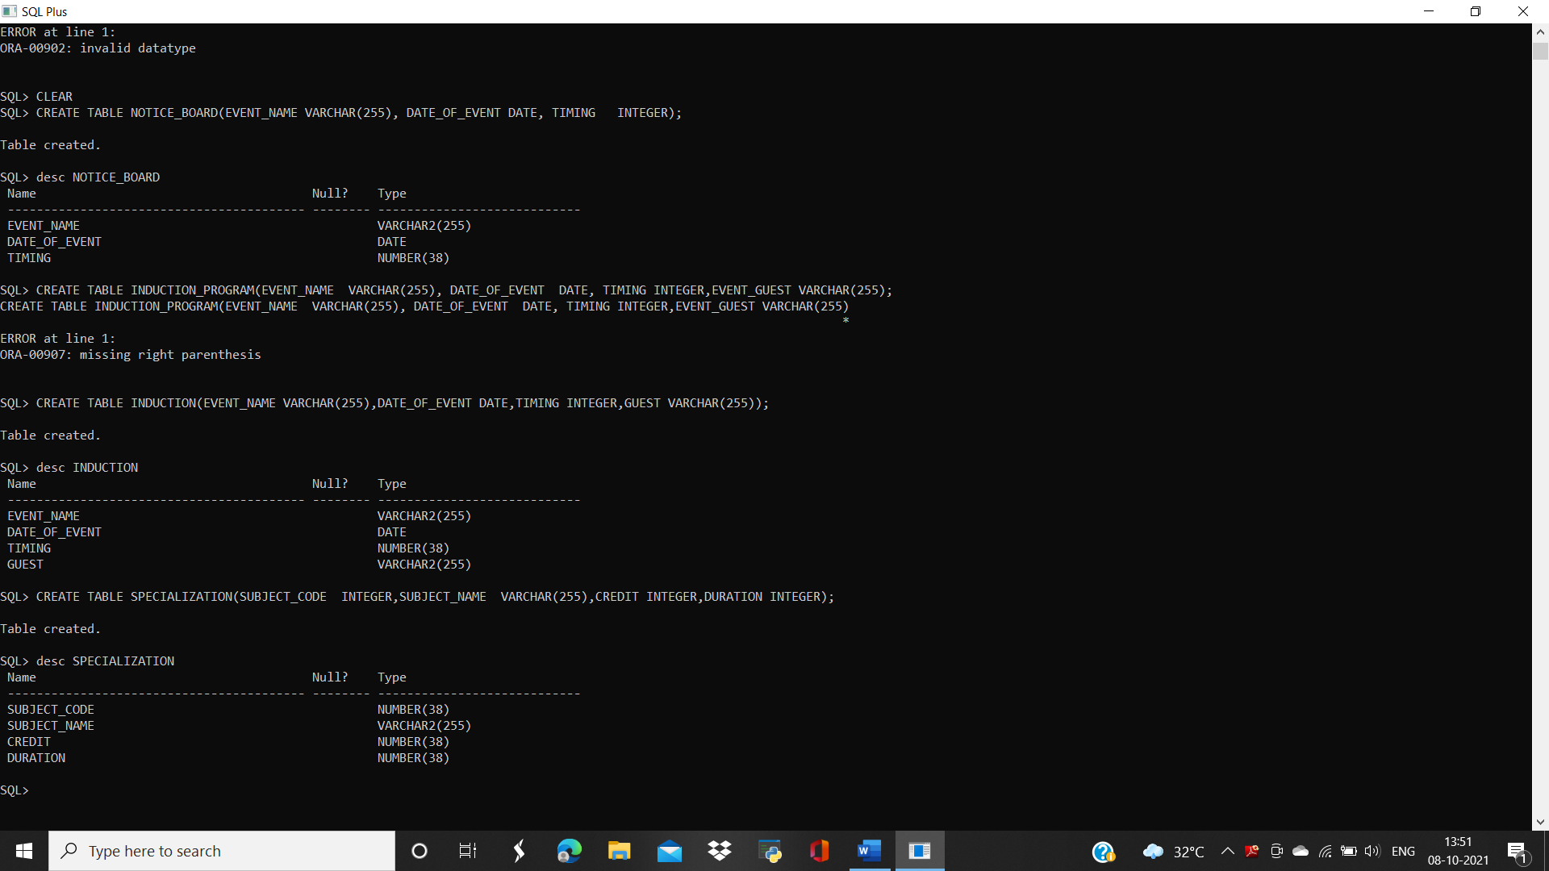

**FILE 07**



**FILE 08**



**MODULE 02 CLUBS AND SOCIETY DEPARTMENT**

**FILE 01**

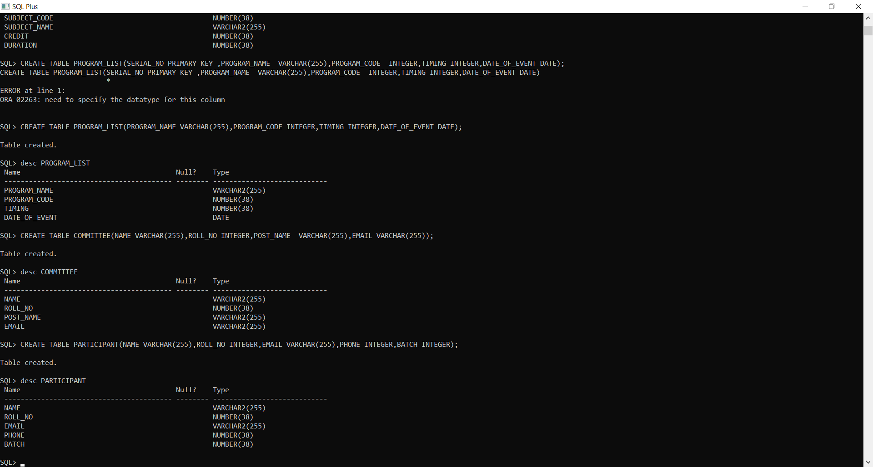

**FILE 02**



**FILE 03**



**MODULE 03 GIRLS HOSTEL DEPARTMENT**

**FILE 01**

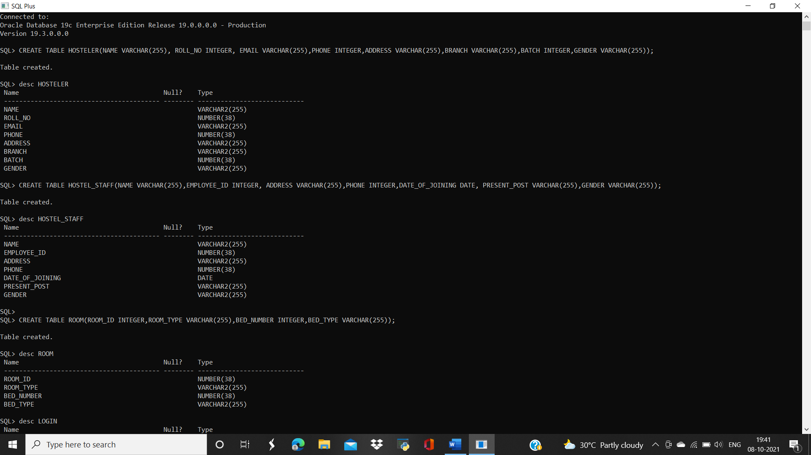

**FILE 02**

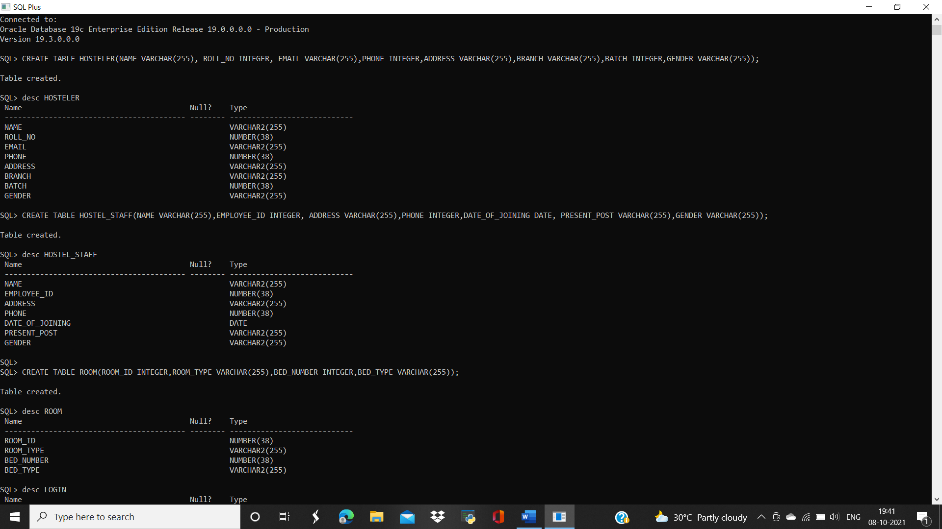

**FILE 03**



**FILE 04**

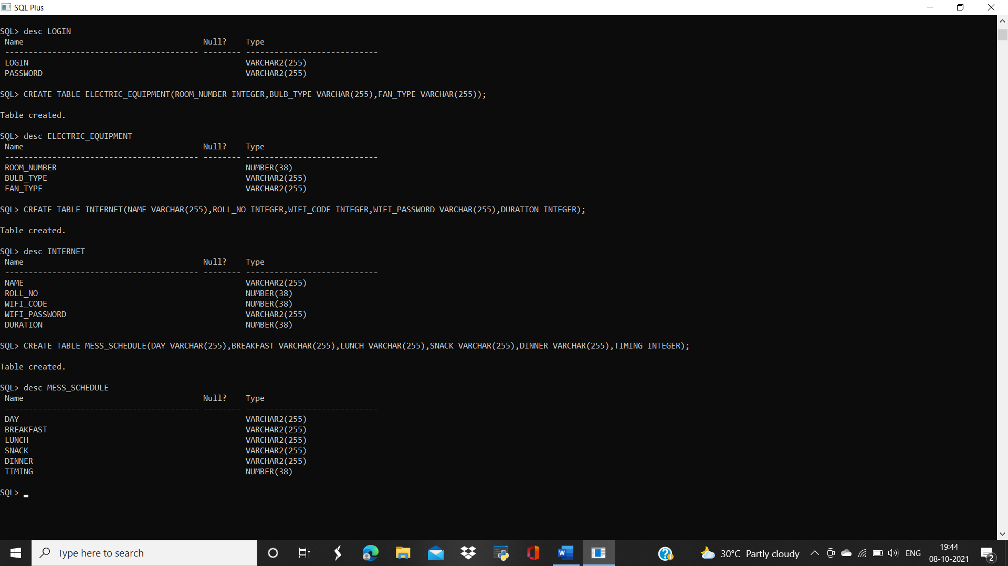

**FILE 05**



**FILE 06**



**FILE 07**



**MODULE 04 EXAMINATION DEPARTMENT**

**FILE 01**

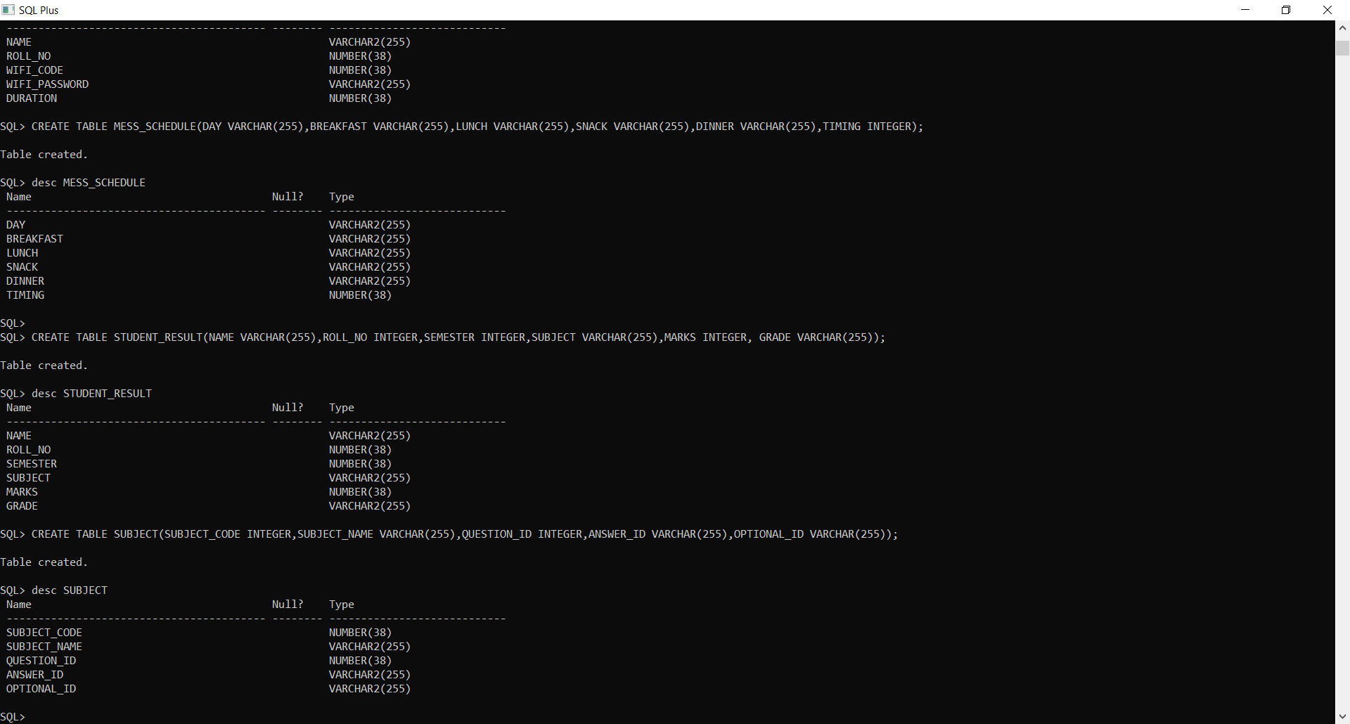

**FILE 02**

